J64 – Build Guide

# Preface

So, you want to build the J64! It will serve you with good fun, and many hours of assembly, programming, and gaming. It is a Raspberry Pi based game console, designed for RetroPie and EmulationStation, enclosed in a 3D printed box.

# Tools Required

Many tools will either be required, or highly recommended for the assembly for the J64. They are listed below, as well as their source from Jaycar.

|  |  |
| --- | --- |
| Logic, Reasoning, and Curiosity | (Note: cannot be found at Maitland Jaycar) |
| Set of Small Screwdrivers | TD2182 |
|  |  |
|  |  |

# Parts Required

Many parts will also be required for construction of the J64. These will be separated into two lists: one for integral parts that MUST be one-for-one, and are designed exactly for the product. The other are parts that can be swapped, or changed, or don’t have to be from Jaycar, such as screws and bolts.

## Exact Match Required

|  |  |  |
| --- | --- | --- |
| Part | Jaycar CAT# | Quantity |
| Round Arcade Switch (Blue) | SP0666 | 3 |
| Round Arcade Switch (White) | SP0669 | 3 |
| Arcade Joystick | SM1052 | 1 |
| Small Normally Open Switch | SP0656 | 2 |

## General Parts

|  |  |
| --- | --- |
|  |  |
|  |  |
|  |  |

# 3D Print

The model for the J64 was done in Fusion 360 and sliced in Creality Print. All files (Fusion 360, STL, and GCODE) can be found in the “Models” directory of the GitHub page.

The 3D Print for this project was done on an Ender 3 V3 KE and finished in just under 4 hours for the body, and 2 hours for the base. It used roughly 1/4 of a 600g roll and didn’t require supports. It did print with a brim, and this was removed with a knife.



CAUTION: when using a knife, never hold the blade towards yourself, and exercise precaution when trimming a brim off a 3D print

# Button Layout

The button layout mimics the MAME button layout, and thus will work best with MAME ROMS. This will be discussed later, when choosing games.

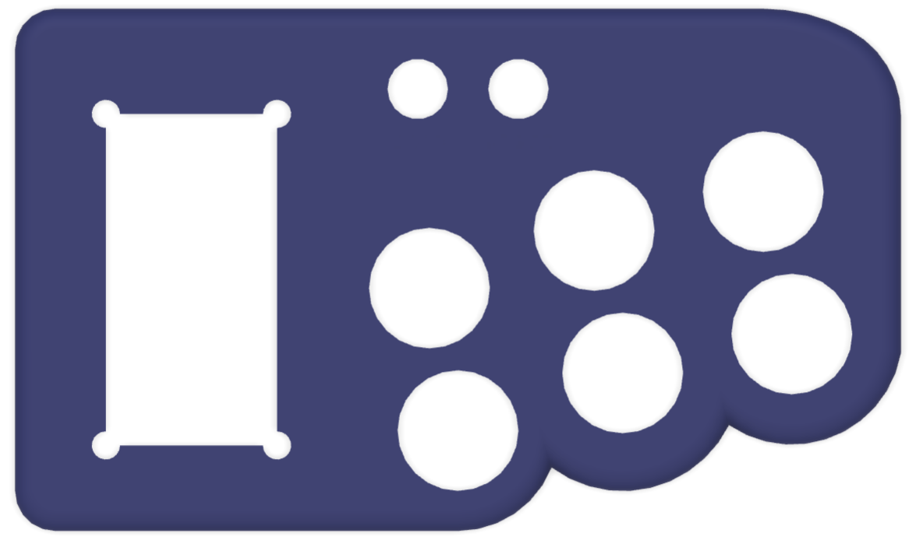

Y

X

L

B

A

R

JOYSTICK

COIN

START

# Assembly

## Buttons

Remove the body of the controller from the print bed. Use care to lift it minimizing damage to both the print bed and the object.

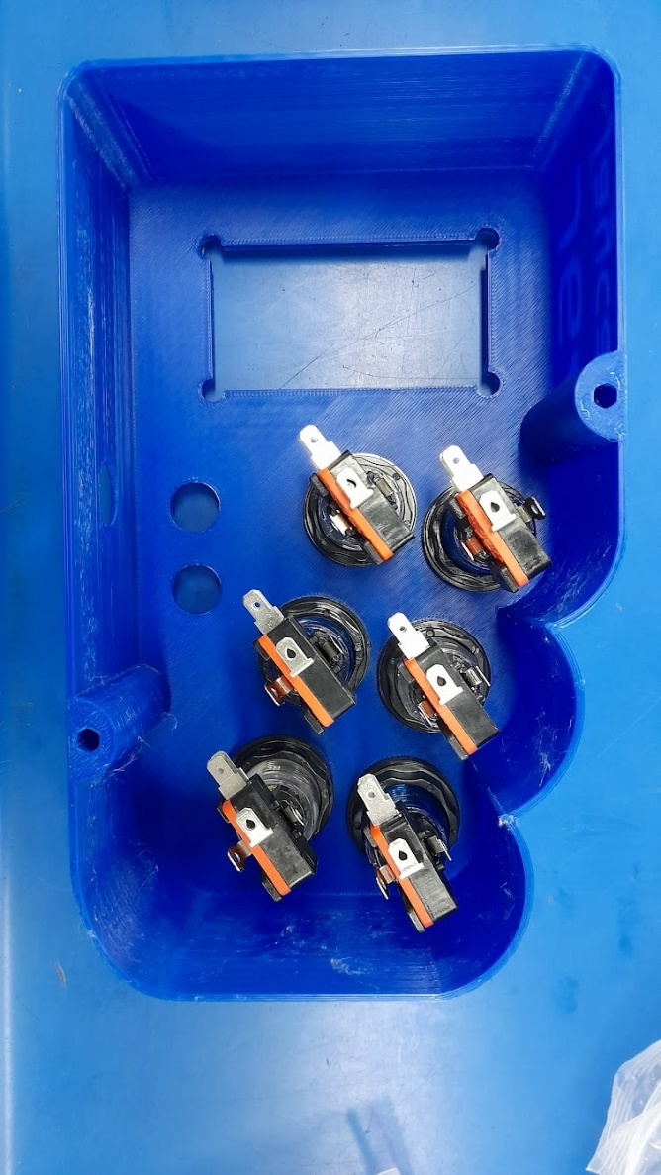

Take the six arcade-style switches, and put the button face through the front of the controller body. Secure them by putting the plastic nuts and washers on, from the other side. Make sure they’re not too tight.

Construct the six switch/light assemblies, by pushing the LED wedge into the socket on the black mount piece, and clipping the switch into the mount piece, paying attention to the dots on the switch, and the holes in the mount piece. Make sure the orange clicky notch on the switch faces towards the LED.

Screw the switch/light assemblies into the switches by means of an eighth turn into the switch clockwise. Note the notches on the lip of the button face to line up the entryway.

Take the four M4 bolts, and four of the nylon spacers, and thread the spacer onto the bolt.

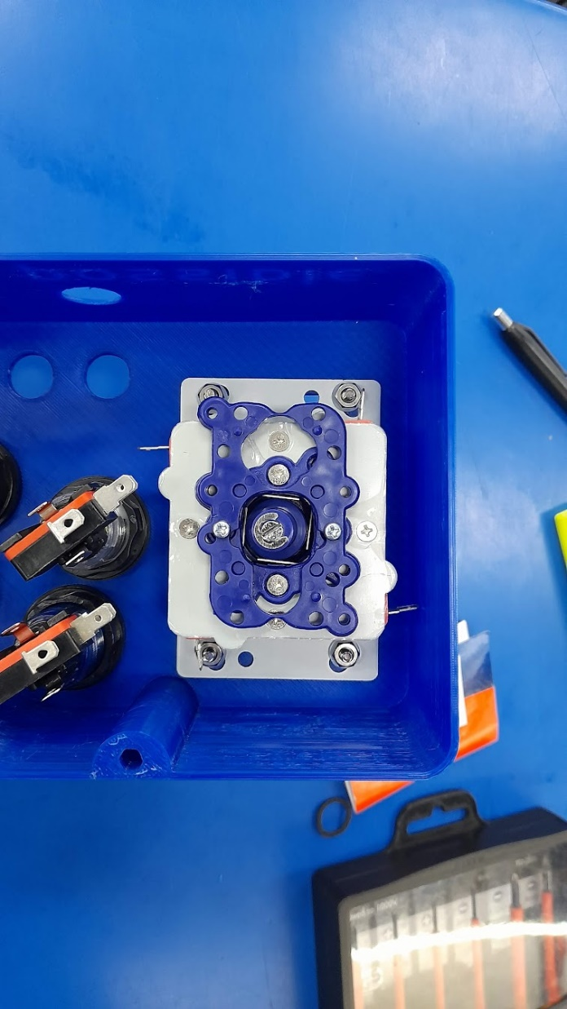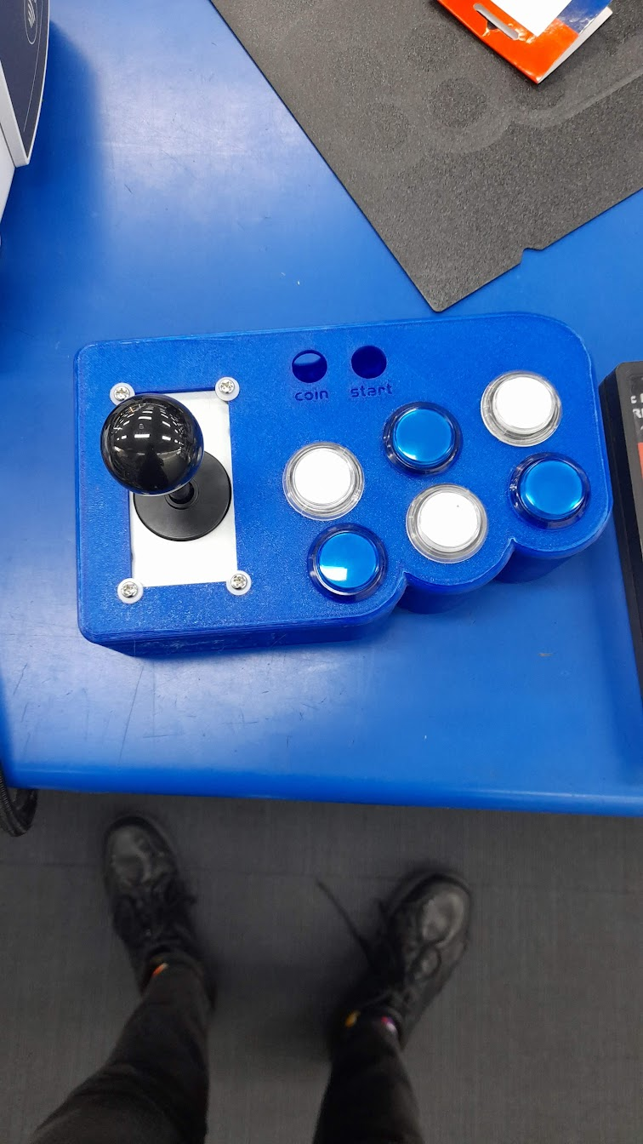Pass the screws with spacers (screw end outside) through the holes on the body where the joystick will sit, and insert the joystick, stick upwards, into the hole. It should line up evenly with the holes. Take the M4 bolts and fasten them up on the underside of the housing.

Pass the joystick’s cover plate onto the stick, and screw the joystick’s ball on top.

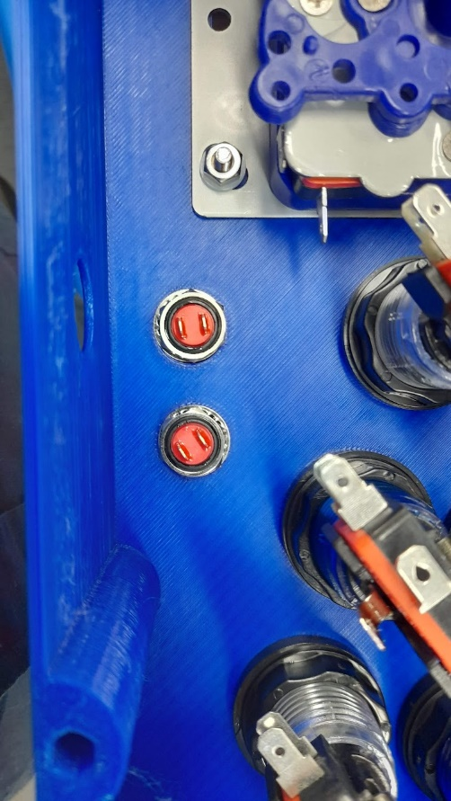Take the black micro buttons, and unscrew the washer and nut from the base.

Pass them through the case, button side up, and tighten the washer and nut back on from the reverse end.

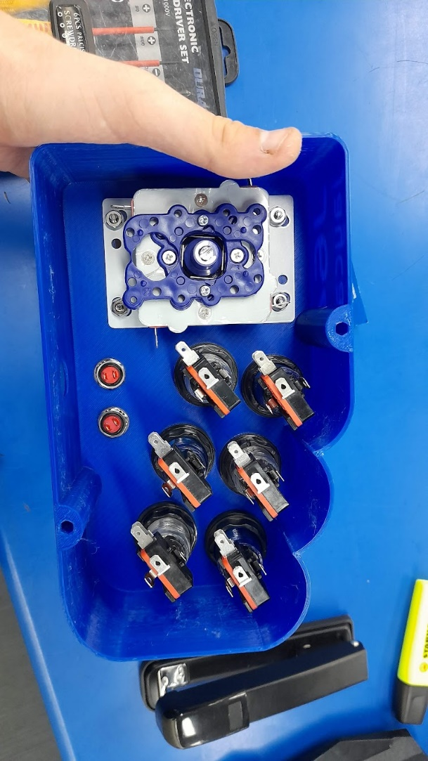Installation of the buttons and joystick is now complete.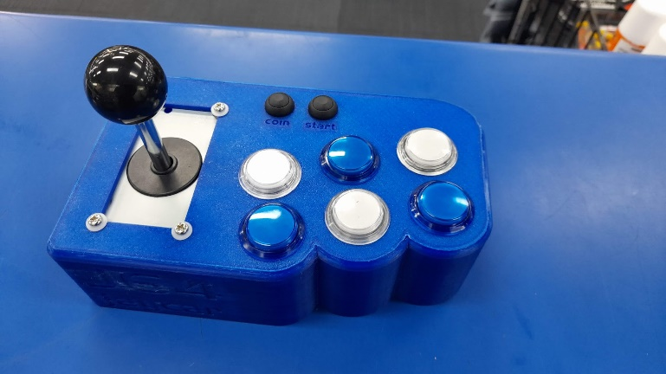 The finished product is pictured below.